Assessment Team Report

The Assessment Team comprised of following three members visited the Department of Human Nutrition on October 03, 2012 in order to assess its Ph.D degree program:

- Prof. Dr. Saleem Khan Convener AT
- Dr. Zia ud Din AT Member
- Mr. Niamatullah Khan AT Member
- Dr. Zafar Iqbal External AT Member

The above team in its meeting with the Program team, QEC officials, Dean and Chairman, identified the following Strength and Weaknesses of the program:

Strengths:

- The current teaching staff is well- qualified. There are three (03) PhDs, two (02) of them are senior Professors.

- The department has one laboratory facility for students.

- The classes are being taught regularly and course contents are completed within the stipulated period.

Weaknesses:

- Lack of Ph.D faculty members in the department.

- Lack of Support personnel for laboratory.

- Lack of Funds for research. The only source is the research projects earned.

- The computer facilities for students within the department are limited and hence the internet facilities are hard to access.
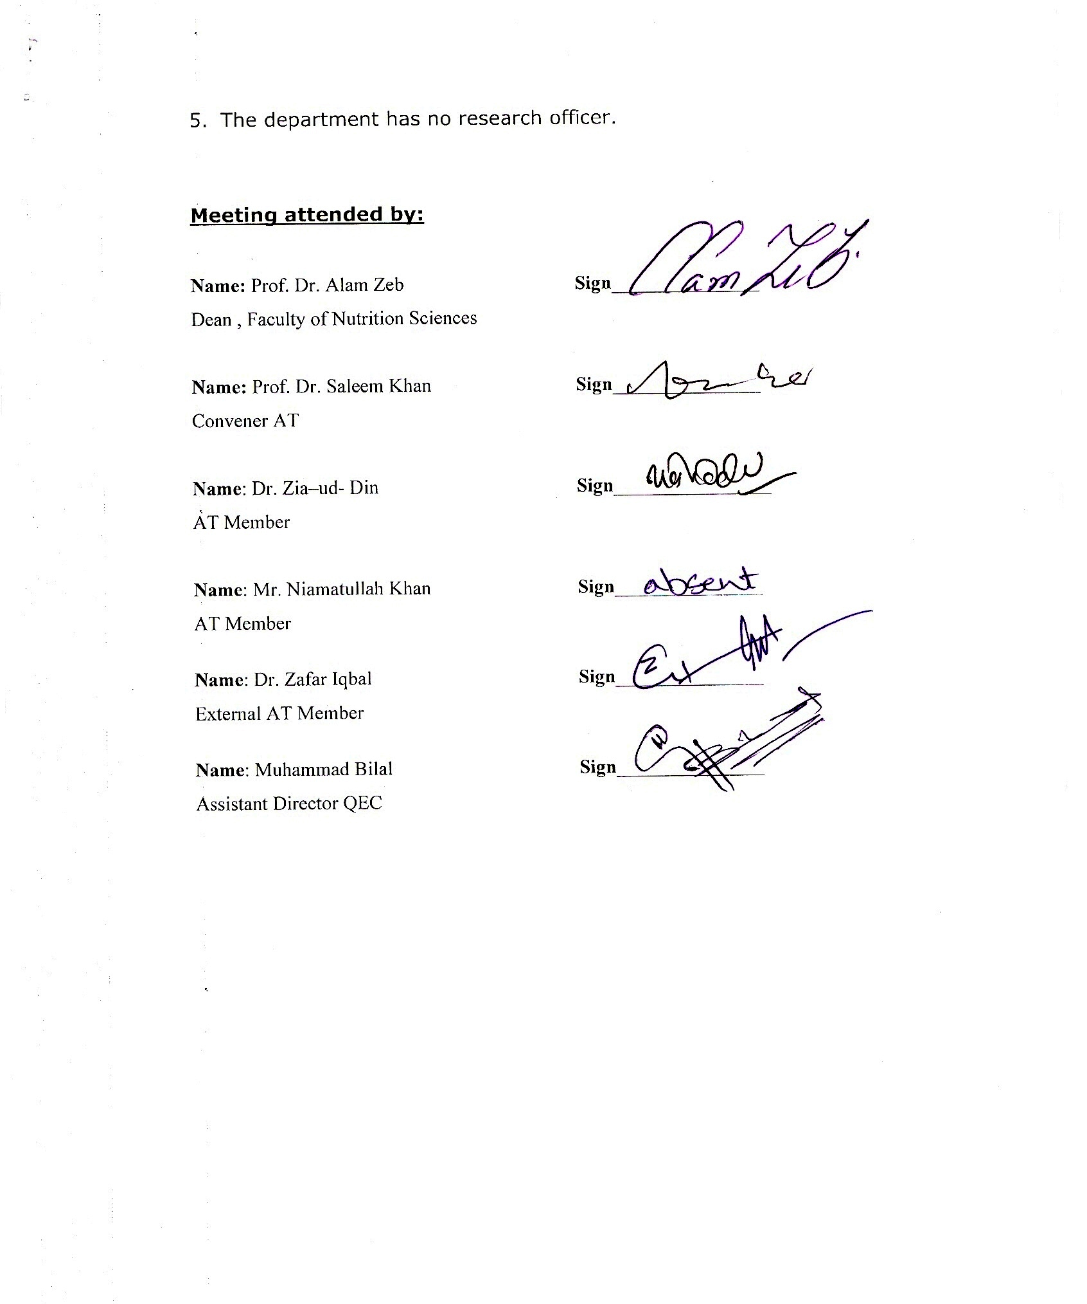

- The department has no research officer.

Meeting attended by:

Name: Prof. Dr. Alam Zeb Sign_______________
Dean , Faculty of Nutrition Sciences

Name: Prof. Dr. Saleem Khan Sign_______________
Convener AT

Name: Dr. Zia–ud- Din Sign________________
AT Member

Name: Mr. Niamatullah Khan Sign_______________
AT Member

Name: Dr. Zafar Iqbal Sign_______________
External AT Member

Name: Muhammad Bilal Sign_______________
Assistant Director QEC

